Newsletter September 2017
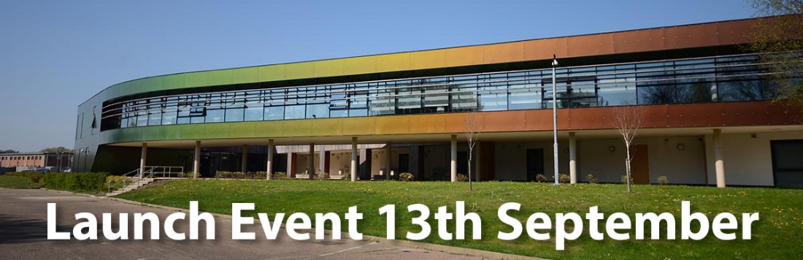
Launch Event, research awards, seminar series, project updates and fellows

We are looking forward to formally launching the unit following our inception in January 2017.
A number of colleagues will be presenting their research on Higher Education. Prior to this exciting event more details can be seen here: http://lncn.eu/launch
Following 13th September please visit the page above for photos and details of the day.

Applications for the Lincoln Higher Education Research Awards close 2nd October 2017
We are offering a number of research awards to a maximum of £750.00 each, primarily for research focused on key issues within higher education and reflected in the University’s Strategic Plan, typically this may include;
- Interdisciplinarity and interprofessional education
- 24/7 campus
- Technology enhanced learning / digital engagement
- Resilience in higher education
- Supporting confidence in students
- Collaboration and partnership approaches
- Inclusivity
However, these themes are broad and submissions outside of these themes will not be discounted.
For more information about the awards and to apply please visit http://lncn.eu/LHERA
Applications close at midnight on 2nd October, all bids will be peer reviewed and we aim to advise all applicants as to the outcome of their submission by 27th October 2017

If you would like to volunteer to peer review submissions, please email LHERI@lincoln.ac.uk

The Lincoln Higher Education Research Institute launch a new e-journal:
SUBMISSIONS NOW OPEN
This academic, peer-reviewed, on-line, open-access journal, has been established as the University of Lincoln’s learned journal on higher education research.
The focus of the journal is higher education and the contexts within which it takes place. Contributions that seek to enhance understanding of any aspect of higher education are welcomed for submission now.
As an online journal we will accept and publish articles throughout the year, however for inclusion in our first edition, to be launched in March 2018, submissions must be made by 30th November 2017
For more information please visit http: http://lncn.eu/impact

You are invited to the Higher Education Research Institute’s
Research Seminar Series
We are developing a series of seminars with a mix of internal and external facilitators. The first will take place on 12th October in JBL3C01 12-2pm with lunch provided:
“Everyone talks about it but no one really knows what it means”: How university students understand the student experience
Prof. Mary Stuart and Dr. Rachel Spacey
Sign up here: https://www.eventbrite.co.uk/e/student-experience-seminar-with-mary-stuart-tickets-35139789055
Further seminars will take place in February, April and June 2018 and details will be included on future newsletters. We are currently in talks with an interesting external facilitator for February’s seminar, do look out for details.

Project Updates
Access Agreement Evaluation Project – Internally Funded
We have recruited two members of staff to lead on this project and look forward to welcoming them to our team in September;
Dr Rachel Spacey – Research Fellow, Rachel joins us after previously working in the VCO, our seminar on 12th October will detail her research in collaboration with Professor Mary Stuart (see previous page)
Jennifer Johnson – Research Assistant, Jennifer has previously worked in the School of Psychology
Developing Academic Leadership and Innovative Practice – Funded by the Leadership Foundation for Higher Education (LFHE) and led by HR
This project has been evaluating a series of interventions piloted over the last year in support of the University’s Programme Leaders with a view to sharing the learning with other HEIs. Enormous thanks to the Programme Leader community for your constructive feedback over the last year, and particular thanks to those who agreed to take part in the final evaluation, and gave up time at a very busy period to help us.
The evaluation report will be published on the Leadership Foundation for Higher Education website in the coming months, and the project team will confirm when it becomes available.
Intervention for Success Project – Funded by the Higher Education Funding Council for England (HEFCE)
This collaborative project between the Universities of Coventry, Huddersfield, Lincoln and Manchester Metropolitan University is progressing well. The project leads, Ben Walker and Alison Wilkinson, are working on the Lincoln strand of the project which currently includes finalising the production of personal tutor resources for staff and students for use in 2017-18. The project will focus on the impact of these in particular focusing on student retention and attainment. Further updates and information can be found on the project website: https://sites.google.com/site/interventionsprojectnews/
Learning Gain Project – Funded by HEFCE
The Get Set Survey is now live, please encourage all students to complete the survey by 1st October 2017. The team will be attending the Senior Tutors’ Forum in early September to discuss the data sets available to them from this survey.
NCOP LiNCHigher Evaluation Project – Funded by HEFCE
The National Collaborative Outreach Programme (NCOP) has the high-level aim of increasing the number of young people from disadvantaged backgrounds in higher education (HE) by 2020. The programme is undertaking outreach activity in geographical areas where the HE participation of young people is both low and much lower than expected based on GCSE-level attainment.
LiNCHigher is supporting this aim by helping schools and educational professionals to enable their pupils to reach their potential, by raising aspirations and increasing successful participation in Further and HE, through the coordination and development of outreach opportunities.
The Lincoln Higher Education Research Institute (LHERI), University of Lincoln, is leading the evaluation strand of the NCOP LiNCHigher project. The evaluation will assess how successfully the programme meets its aims. The next stage of the research will be a baseline survey of approximately 22,000 13 to 18 year old students across the whole of Lincolnshire.
Fellows of the Lincoln Higher Education Research Institute
Please see details of some of the fellows in our network below.
Registering as a fellow provides you with an opportunity to be a part of a growing network of Higher Education researchers and to join our mailing list and to promote your work on our website. All staff and postgraduate students are invited to join our network of fellows and associate fellows, for more information on our current fellows and to apply please visit https://heri.blogs.lincoln.ac.uk/fellows/

