Newsletter September 2017

Spotlight on a fellow of the Lincoln Higher Education Research Institute
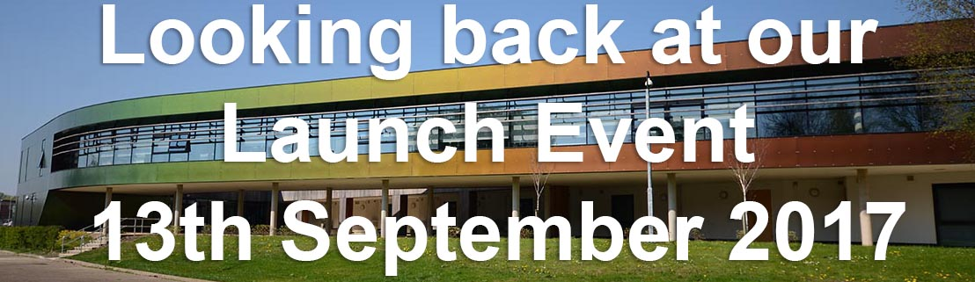
We have a new feature in this newsletter. Please see the back page of this newsletter and each future edition, where you will find information about the research work of a fellow of the research institute. For this first spotlight article, Keivan Ahmadi has kindly provided an overview of his Higher Education research interests.
We are delighted with the success of our launch event which took place last month. Thank you to all colleagues who contributed and attended the event. Full details can be found on our website linked below, including information about the posters contributed by colleagues showcasing their Higher Education Research projects. http://lncn.eu/launch

The Lincoln Higher Education Research Institute launch a new e-journal:
WE ARE NOW OPEN FOR SUBMISSIONS TO THE JOURNAL!
This academic, peer-reviewed, on-line, open-access journal, has been established as the University of Lincoln’s learned journal on higher education research. The focus of the journal is higher education and the contexts within which it takes place. Contributions that seek to enhance understanding of any aspect of higher education are welcomed for submission now.

As an online journal we will accept and publish articles throughout the year, however for inclusion in our first edition, to be launched in March 2018, submissions must be made by 30th November 2017
For more information please visit http: http://lncn.eu/impact
Applications now closed for the Lincoln Higher Education Research Awards
Thank you to everyone who applied for these research awards. Applications are now in the process of double blind peer review. We aim to advise all applicants as to the outcome of their submission by 27th October 2017. Look out for our November newsletter when we will publish details of successful submissions.

You are invited to the Higher Education Research Institute’s Research Seminar Series
We are now operating a waiting list for our first seminar of this series with Prof. Mary Stuart and Dr. Rachel Spacey on 12th October 2017. Please see details here: http://lncn.eu/seminar1
Our second seminar of the series will take place on 2nd February 2018 with Professor Paul Wakeling of the University of York:
What does it mean to ‘widen participation’ at postgraduate level?
Please see http://heri.blogs.lincoln.ac.uk/events/seminarfeb17/ for more details.

Higher Education Research Institute Project Updates

Access Agreement Evaluation Project – internally funded
Both Rachel Spacey, Research Fellow and Jennifer Johnson, Research Assistant started in LHERI in late September 2017. They are meeting with relevant university colleagues as they begin the process of drafting the evaluation project plan for approval through the project’s governance structure.
Developing Academic Leadership and Innovative Practice – funded by the Leadership Foundation for Higher Education (LFHE) and led by HR
This project has been exploring a series of interventions piloted to support Programme Leaders here at the University of Lincoln. Research interviews and data analysis are now complete and the case study report is being reviewed. A short summary of a strand of the research was presented at the recent LHERI launch conference, and it was great to hear from the other project leads and see the fabulous posters. Heartfelt thanks to everyone who supported and contributed to the report, formally or informally- it would not have been possible without you. The LALT Engagement Team are now combining their own expertise with the learning from the project to take forward the professional development opportunities available for Programme leaders and other academic staff members- head over to https://lalt.lincoln.ac.uk/ to find out more about current opportunities, or straight to the training portal page to book onto a course.

Intervention for Success Project – Funded by the Higher Education Funding Council for England (HEFCE)
The personal tutor resources for staff and students are now ready for use and can be found at:
http://lncn.eu/ptmaster Resources can be duplicated and adapted by staff for use with their particular cohort of students.

The staff resources will inform a personal tutor staff development programme starting in January 2018. The project leads, Ben Walker and Alison Wilkinson, would like to receive any feedback here: http://lncn.eu/feedback1

Learning Gain Project – Funded by HEFCE
There has been an excellent student response to this year’s Get Set Survey. Already, 2826 Level 1 students have completed the survey, meaning that we have obtained valuable data from over 70% of the new intake. Inevitably, responses from Levels 2-6 have been substantially lower, but we remain optimistic that we will obtain data from some hundreds of returning students. In response to demand from Heads of School and Senior Tutors an initial report on Level 1 data has already been issued, and this will be followed up with a detailed analytical report once the administration closes. We have decided to extent the end date to 30 October in order to maximise the number of L2 and L3 responses. PLEASE ENCOURAGE ALL STUDENTS TO COMPLETE THE GET SET SURVEY. We have also commenced the administration of the latest round of the Student Self-Assessment and have employed a number of Student Ambassadors to incentivise participating students. Our next major milestone will be submission to HEFCE of the project’s second Interim Monitoring Report (due 27 October).
NCOP LiNCHigher Evaluation Project – Funded by HEFCE
The National Collaborative Outreach Programme (NCOP) has the high-level aim of increasing the number of young people from disadvantaged backgrounds in higher education (HE) by 2020. The programme is undertaking outreach activity in geographical areas where the HE participation of young people is both low and much lower than expected based on GCSE-level attainment.
LiNCHigher is supporting this aim by helping schools and educational professionals to enable their pupils to reach their potential, by raising aspirations and increasing successful participation in Further and HE, through the coordination and development of outreach opportunities.
The Lincoln Higher Education Research Institute (LHERI), University of Lincoln, is leading the evaluation strand of the NCOP LiNCHigher project. The evaluation will assess how successfully the programme meets its aims. The next stage of the research, a baseline survey of approximately 22,000 13 to 18 year old students across the whole of Lincolnshire, will be launched this month.

Spotlight on a fellow of the Lincoln Higher Education Research Institute

Dr. Keivan Ahmadi
Interdisciplinary/Inter-professional Education: A Catalyst for Professional Identity Formation
Keivan is a Senior Lecturer in the School of Pharmacy and joined the Institute as a Fellow in September 2017. Keivan’s higher education research interests focus on Pharmacy Education but within the wider landscape of Health Education. In particular Keivan has been working with the Institute to develop research in inter-professional education (IPE).
According to the Centre for Advancement of Interprofessional Education (CAIPE), IPE occurs when two or more healthcare professionals – healthcare profession students – learn with, from and about each other to provide the quality care/service. With an emphasis on word “I”, IPE can create a safety net to contain and consolidate “interdisciplinary initiation” of education, “integration” of curriculum outcomes across disciplines, “interpretation” of real life scenarios to educational scenarios; and most importantly the professional “identity” formation of our students to become excellent professionals.
Fortunately, the idea of interdisciplinary/inter-professional education is strongly reflected in the University of Lincoln’s Strategic Plan 2016-2021, to create an open university that encourages and supports collaborative working across the disciplines. One of the main objectives of Lincoln IPE Steering Group (LIPESG) is to enable students to have regular meaningful interaction with a range of other disciplines. Therefore, LIPESG has been instrumental in encouraging and supporting IPE activities across the College of Science, College of Social Science, Lincolnshire Partnership Foundation Trust (LPFT), etc. These IPE activities are divided into four main categories i.e., on campus, on placement, on-line and in research. The on Campus, on placement and on-line IPE activities have been a success and will continue to grow in the coming years.
From the research point of view, Keivan has been working with a group of academics from the School of Pharmacy to submit a proposal to Lincoln Higher Education Research Award call that aims at understanding of the relationship between IPE activities and professional identity formation through content/thematic analysis of reflective essays of MPharm students.
For further information please contact Keivan directly kahmadi@lincoln.ac.uk 5874
Register as a fellow
This provides an opportunity to be a part of a growing network of Higher Education researchers and to join our mailing list and to promote your work on our website. All staff and postgraduate students are invited to join our network of fellows and associate fellows, for more information on our current fellows and to apply please visit https://heri.blogs.lincoln.ac.uk/fellows/

