Critical explorations of Learning Gain

Three members of the LHERI team travelled down to The Shard in London last week for a meeting organised by the LEGACY project on Critical Explorations of Learning Gain.
On arrival we were met with spectacular views across London which were admired by all over a tasty breakfast. It really was a stunning venue to take time out to think about practical and political challenges of measuring learning gain.
Paul Ashwin (Lancaster University) opened the day with a thought provoking keynote which probably challenged parts of the approach of all of the pilot projects in the room as he questioned the validity of using both ‘big data’ and ‘silver bullets’. His core argument was that higher education should be knowledge based and should change students’ sense of self through discipline and professional training. He argued that how universities deliver this knowledge is location and context specific and universities should be encouraged to identify what it is they do well and market this to potential students. Rather than focusing on a one-size fits all framework, he suggested a pragmatic approach where the measurement of learning gain benefits students both directly, and through teaching enhancement. This very much fits in with the ethos of the Learning Gain project at Lincoln where we have been proactive in highlighting the benefits to students of taking part in the study and in using the results to improve teaching and learning across campus.
Although Paul Ashwin made us all think, the reality is that there is a need for some kind of framework to measure learning gain at different universities and provide a means to help identify where individual institutions are good at developing particular skills in students. Iain Mansfield (Department for Education), while acknowledging the challenges, didn’t’ shy away from articulating the Government’s desire to move towards this goal.
The project updates from some of the pilot Learning Gain projects throughout the day demonstrated that valuable progress is being made towards this goal. They also provided a great opportunity to share learning as many of the issues we have experienced in the Lincoln project are also reflected at other universities. For example the challenge of encouraging students to actively partake in assessments (e.g. Stuart Brand, Birmingham City University), or career development activity (e.g. Legacy Project R2 strand), and to explore different options for analysing and presenting data (e.g. Sonia Ilie, University of Cambridge).
As the pilot projects move into their final year, what is needed now is a coherent review of the strengths and weaknesses of the multiplicity of approaches that have been tested, and a clear framework established for identify how these could be combined into a valid measure (or suite of measures) of learning gain. There remains a lot of work to do particularly for the Programme Evaluator (Camille Kandiko Howson)!
Many thanks to the LEGACY project team for organising and hosting the day and providing such a unique venue.
Figure 1Breakfast with a view!
Figure 2 Paul Ashwin's suggestions for the key characteristics of valid measures of teaching quality
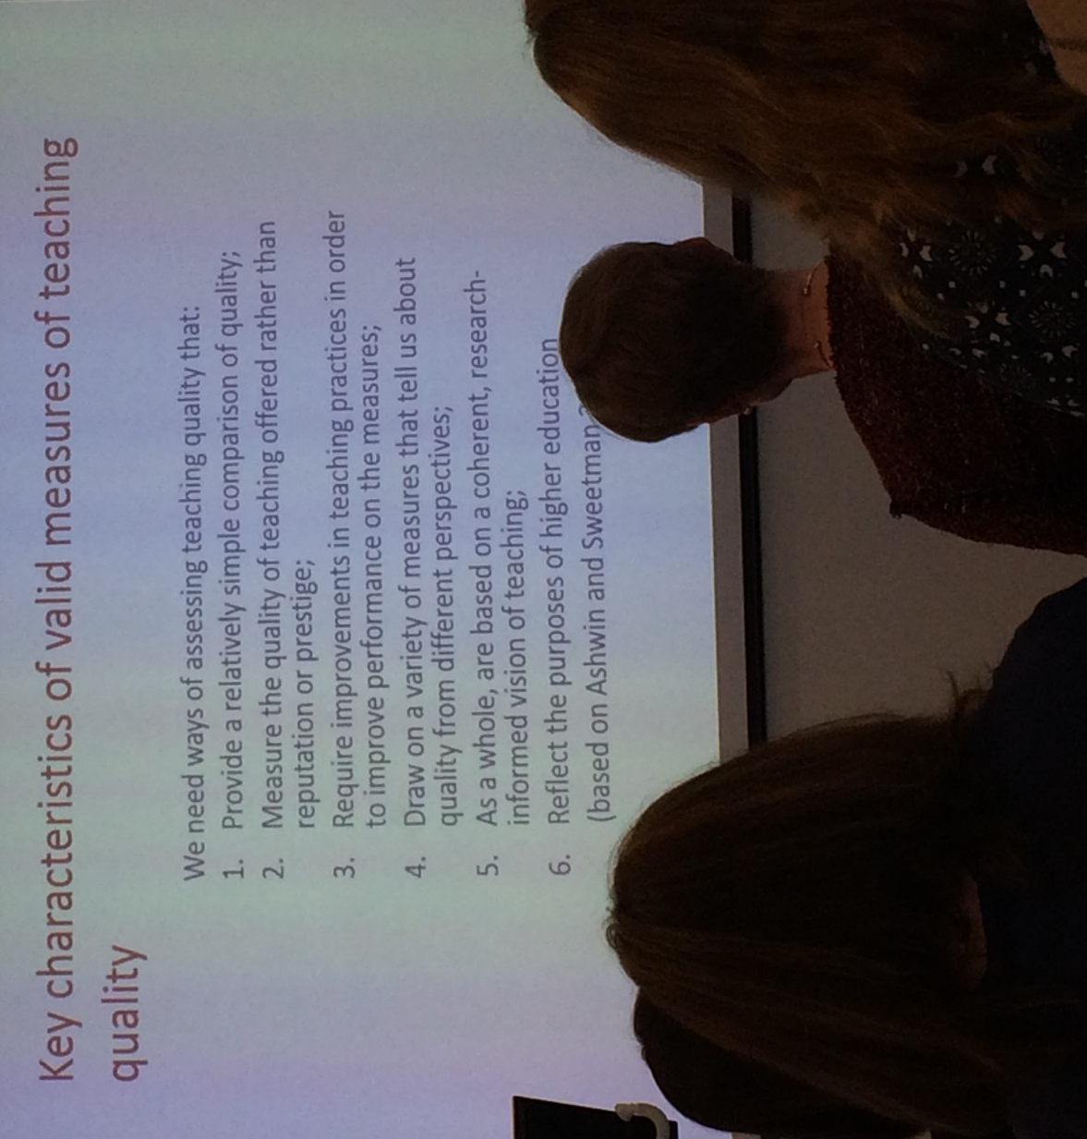
Figure 3 Event logo https://www2.warwick.ac.uk/services/aro/dar/quality/legacy/futureevents/

